Student worksheet

4.5 Visible light is a small part of the electromagnetic spectrum

Pages 78–79 and 196

The electromagnetic spectrum

1 What is the electromagnetic spectrum?

2 Which part of the electromagnetic spectrum do we see?

3 How does light on the electromagnetic spectrum vary?

4 Compare and contrast light and sound waves.

5 Draw a light and a sound wave below to illustrate the main difference between them.

|  |  |
| --- | --- |
| a Light wave: | b Sound wave: |

6 Label the wavelength (and identify it as long or short) and the amplitude of the following light waves.

|  |  |  |  |  |
| --- | --- | --- | --- | --- |
| a | SW0412_01026-r |  | b | SW0413_01026-r |
|  |  |  |  |  |

7 On the diagram above, identify low and high frequency and what it is measured in.

8 How fast is the speed of light?

9 Why do astronomers say that when we look at the stars we are looking back in time?

Extend your understanding

In 1919, Edwin Hubble was working on the Hooker telescope in Los Angeles. He used a spectrograph to look through the telescope at the galaxies and could relate what he found to the Doppler Effect. The Doppler Effect is the change in frequency of a wave for an observer moving relative to its source. What this means is that if you are standing on a road and a car drives by you, it will sound different when it approaches compared to when it is moving away.

10 When a car moves toward you do you hear a high- or low-pitch sound?

11 Is this high or low frequency?

12 Does this frequency correlate to red or violet on the electromagnetic spectrum?

13 When a car moves away from you do you hear a high- or low-pitch sound?

14 Is this high or low frequency?

15 Does this frequency correlate to red or violet on the electromagnetic spectrum?

16 What did this imply, if the majority of galaxies that Hubble saw when he looked through the Hooker telescope were red?

17 If you rewound time, what would happen to these galaxies?

18 What scientific theory did Hubble develop using this evidence?

Student worksheet

4.6 Light reflects off a mirror

Pages 80–81 and 197–199

Reflection of light

1 Match the word with its definition below.

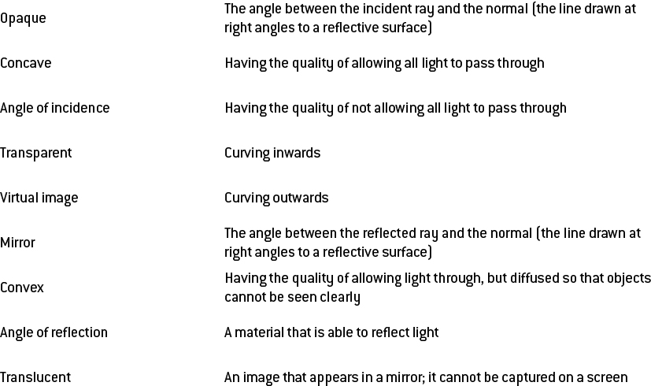

2 Name the quality and give an example of the type of object that will:

a let light pass through

b block light

c only allow some light through

3 For the following mirror, draw the normal, the angle of incidence, the angle of reflection and label the incident and reflected rays.

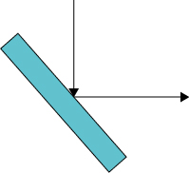

4 What is the relationship between the angle of incidence and the angle of reflection?

5 What do you see when you look in a plane mirror?

6 Draw a diagram of a concave and convex mirror in the space below and give a real world example of where they are used.

|  |  |  |  |
| --- | --- | --- | --- |
| a | concave:  SW0422_01026 | b | convex:  SW0422_01026 |
|  |  |  |  |

Extend your understanding

7 Investigate reflecting telescopes and draw a diagram of a Gregorian and Newtonian reflecting telescope below. In both cases, label the incident and reflected rays and the mirrors involved, and explain how they work.

a Gregorian:

b Newtonian:

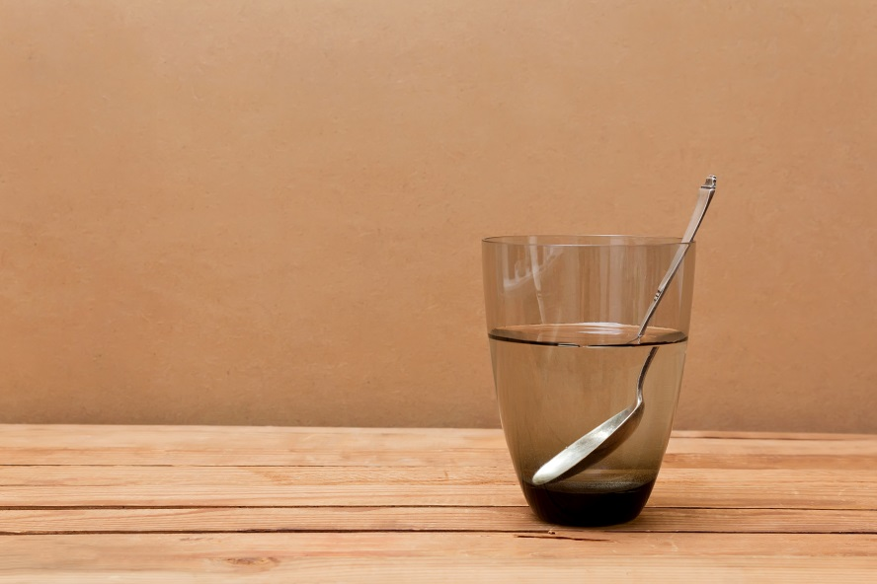Student worksheet

4.7 Light refracts when moving in and out of substances

Pages 82–83 and 199–200

Refraction of light

1 What is refraction?

2 What is the result of refraction?

3 What does the bending of light depend on?

4 On the following diagram label the normal, incident ray, the angle of incidence, the refracted ray, and the angle of refraction

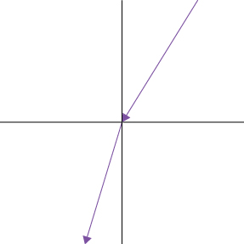

5 Is this form or refraction from water into air or air into water? Explain how you know.

6 Explain how refractive index relates to density.

7 Why does light bend and how does this relate to a materials refractive index?

8 When is the only time that light does not bend?

9 What is a lens?

10 Draw a diagram of a concave and convex lens, demonstrating their convergence or divergence and focal length and focus point or virtual focus.

|  |
| --- |
|  |

Extend your understanding

11 Light bends and disperses when it passes into a prism and then back out into the air again. The refractive index of air is 1.0 and of the glass prism is 1.5.

a Why does light refract multiple times when moving through a prism?

b What is dispersion and how does white light disperse?

c Why does light disperse as it moves from air into a glass and then back out into the air?

d Describe the direction that the light will bend (toward or away from ther normal) when it moves from the air into the glass.

e Describe the direction that the light will bend (toward or away from ther normal) when it moves from the glass into the air.

Student worksheet

4.8 Different wavelengths of light are different colours

Pages 84–85 and 201

Visible light is colour

1 What is dispersion?

2 Which colours does white light separate into? How can you remember these?

3 What is unique about each colour?

4 What is this range of colours called?

5 What are primary colours?

6 What are secondary colours?

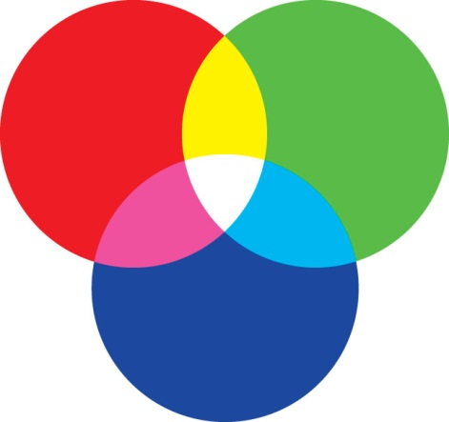7 What are complimentary colours of light? How would you create them? Use the colour diagram to help you explain this.

8 Which colours would you add to make white light if you started with the following:

a red

b blue

c green

d yellow

e cyan

f magenta

9 Why do the leaves of plants appear green?

10 Your boss hires you to grow a crop of plants and wants you to use optimal abiotic conditions only. What light would you use?

11 Determine which colours are absorbed and transmitted by cellophane which is coloured:

a blue

b magenta

c cyan

d green

Extend your understanding

12 At some point in your life, someone has probably told you that the sky is blue because if reflects the ocean, but this is not correct. Using the knowledge you have gained from pages 84 and 85, explain why the sky is blue.

13 Just as the sky is blue, a sunset appears red. Using the knowledge you have gained from pages 84 and 85, explain why a sunset is red.

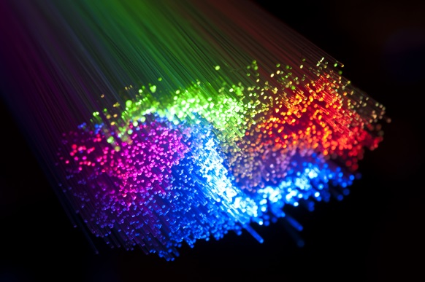Student worksheet

4.9 The electromagnetic spectrum has many uses

Pages 86–87 and 202

Uses of the electromagnetic spectrum

1 What happens when light rays pass into a less dense medium at a very large angle?

2 What is this phenomenon called?

3 What are the applications for this phenomenon?

4 What is a prism?

5 What happens to light as moves into a less dense medium?

6 What is the critical angle?

7 What is an optic fibre?

8 What is the function of an optic fibre?

9 What is the potential use of optic fibres?

10 What material will they end up replacing?

11 What is the difference between what these two materials are able to do/carry?

12 What are the advantages of optic fibres over copper wires?

13 How big are microwaves and what are they?

14 What are the applications of microwaves?

15 How are they used for communication?

16 How are microwave ovens able to heat food?

Extend your understanding

17 The electromagnetic spectrum can be used in analytical chemistry to determine the structure of a chemical molecule. Conduct research on the following analytical chemical techniques and identify the type of radiation involved and what it is able to tell you about a molecule.

a infrared spectroscopy

b UV-visible spectroscopy

c hydrogen nuclear magnetic resonance spectroscopy

d carbon nuclear magnetic resonance spectroscopy

Student worksheet

4.10 Our eyes detect light

Pages 88–89 and 203–204

The structure and function of the eye

1Label the structure of the eye**.**

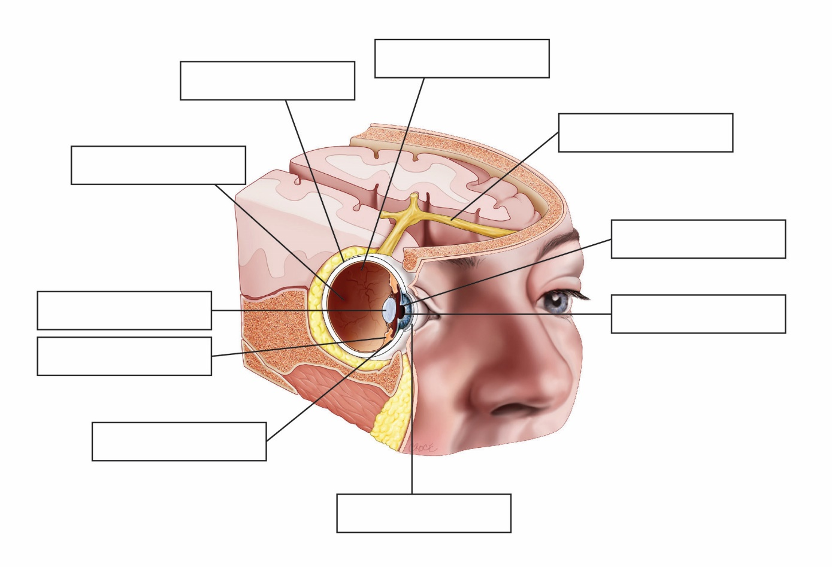

2 Match each structure within the eye to its correct function.

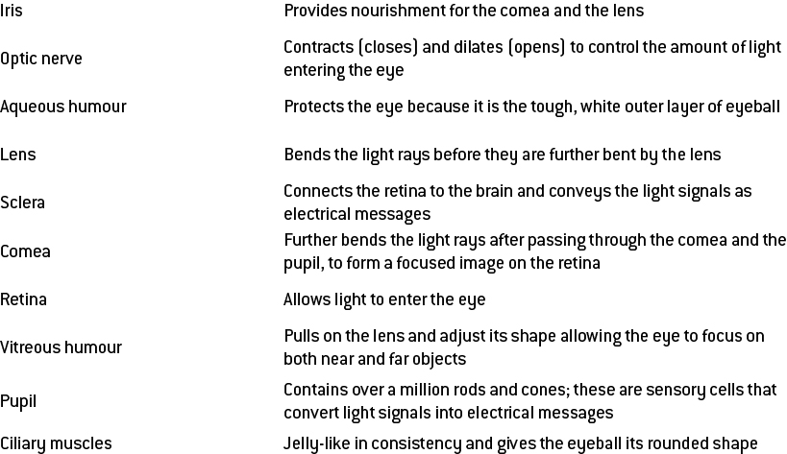

Extend your understanding

3Using as much of the light terminology as you have learnt, explain the path that light waves must follow through the eye and how they are converted into electricity before being transferred to the brain.

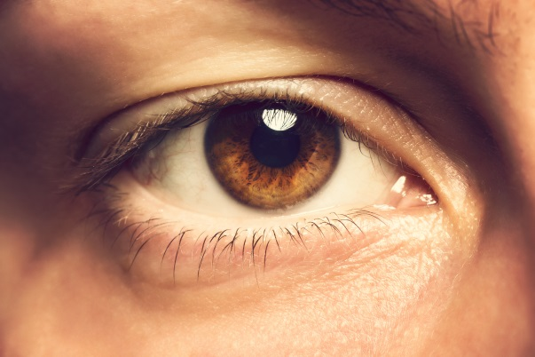Student worksheet

4.11 Things can go wrong with our eyes

Pages 90–91 and 205

Problems with sight

1 What is myopia?

2 What is myopia described as?

3 What causes myopia?

4 How can myopia be treated?

5 Draw a diagram of the eye focusing light rays before and after a lens is used (include the lens):

|  |
| --- |
|  |

6 What is hyperopia?

7 What is hyperopia described as?

8 What causes hyperopia?

9 How can hyperopia be treated?

10 Draw a diagram of the eye focusing light rays before and after a lens is used (include the lens).

|  |
| --- |
|  |

11 What is the cause of colour blindness and what is the effect?

12 What is the cause of cataracts?

13 What do cataracts lead to?

14 How can cataracts be treated?

15 What is the cause of astigmatism?

16 What can astigmatism lead to?

17 How can astigmatism be treated?

Extend your understanding

18 Choose one of the 3 vision problems below and answer the questions that follow.

esotropia (mistakenly called lazy eye), glaucoma, pterygium (surfer's eye)

a In which visual structure/s does the condition occur?

b What is the cause?

c What effects can it have on your sight?

d What is the treatment?

e Is there any way to manage the condition/limit ongoing effects?